Git Assignment By Lohit Ahooja

1. Git configuration has been done and the ssh key has also been attached
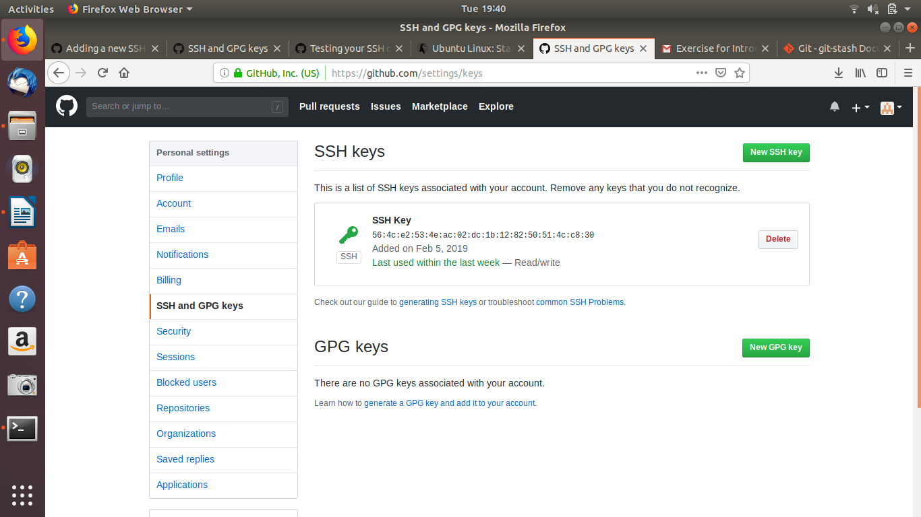
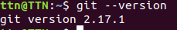

2.git init command is used to initialize

making a directory of the project

changing the directory to the project file

initializing git repository in it

3.
making of file in the project directory
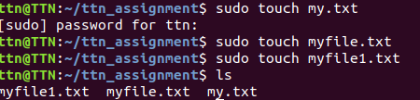

Now addding files to the repository

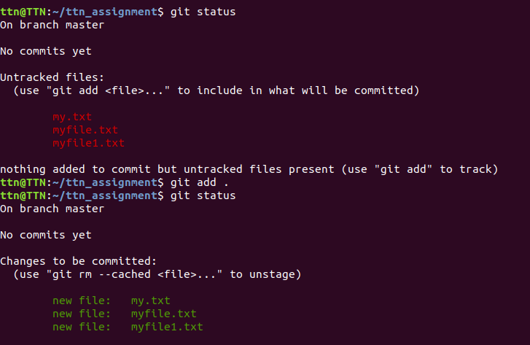
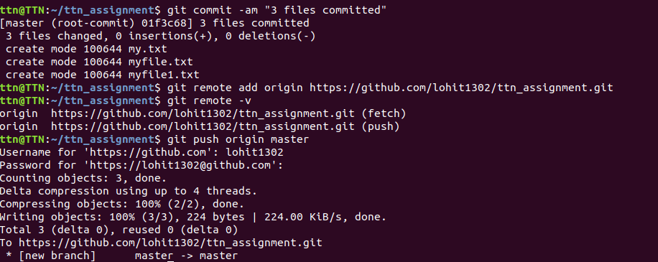
Pushing files to the remote server

4.using git reset HEAD filename to unstage the filename

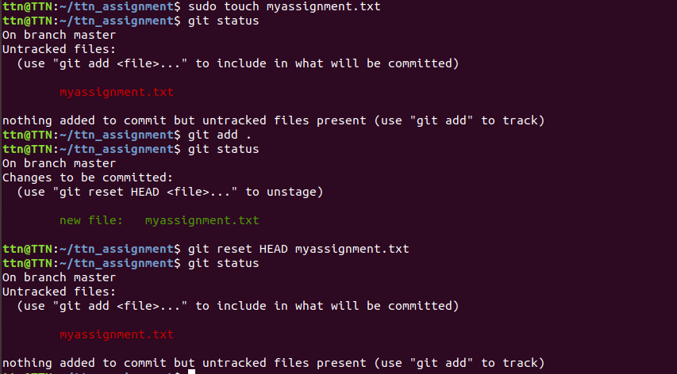

5. committing the files using git add . followed git commit -m “Message” or git commit -am “Message” to add and commit simultaneously

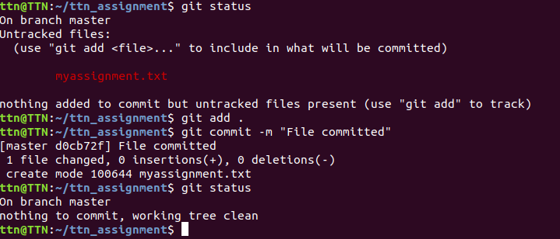
6.
adding remote using command git remote add “remote origin name” URL
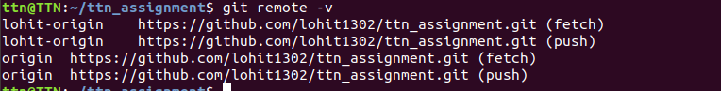
7.
using git checkout “commitid” “name_of_file”
used git log -1 to find the log of the previous commit
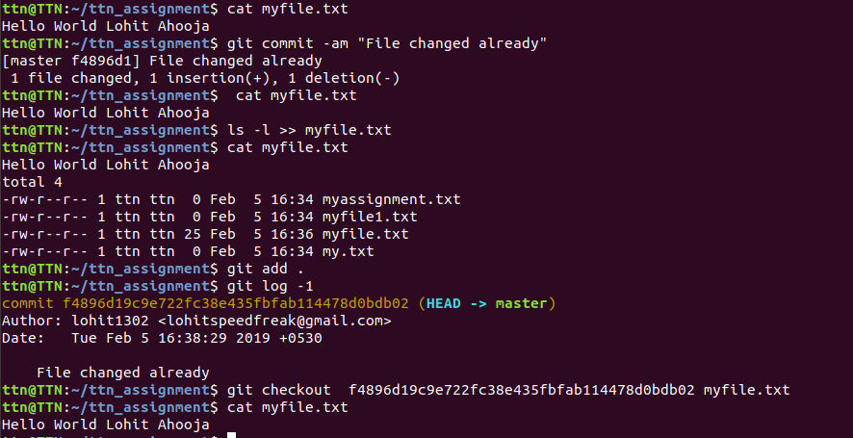
8.
using git push origin master followed by username and password the github account
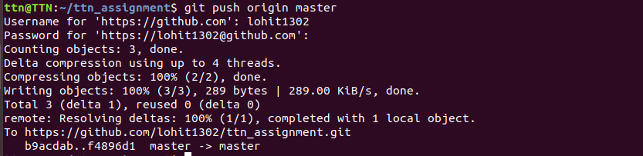

9. using clone git clone “Repo. URL”

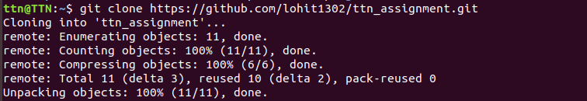
10.
pushing myfile.txt in the Repo

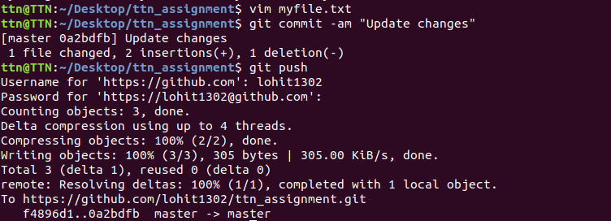

Entered content in the myfile.txt
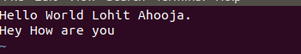

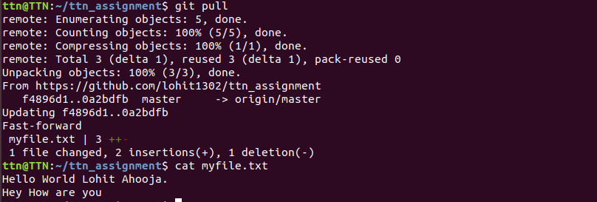
Pulling from Repo in the Other copy

11. using command git diff –staged to checkout difference between both the files commited and uncommited file

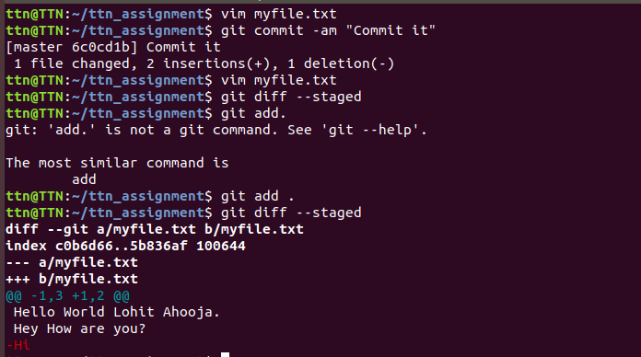

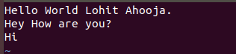
Contents of the file before and after the committed



12.

adding file name in .gitignore file
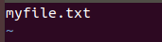

Content of file before adding name

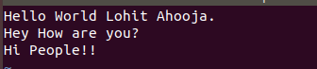

Contents of file after adding name

Pushed the Local Repo To Remote Repo

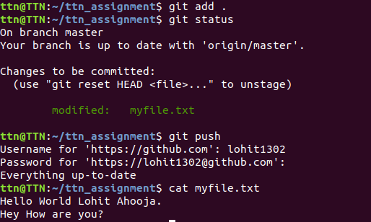

Remote Repo Pictures

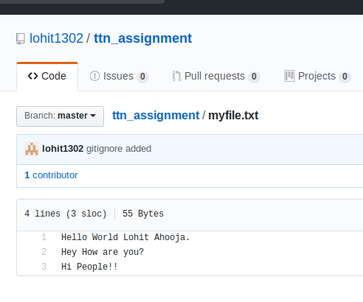

13.
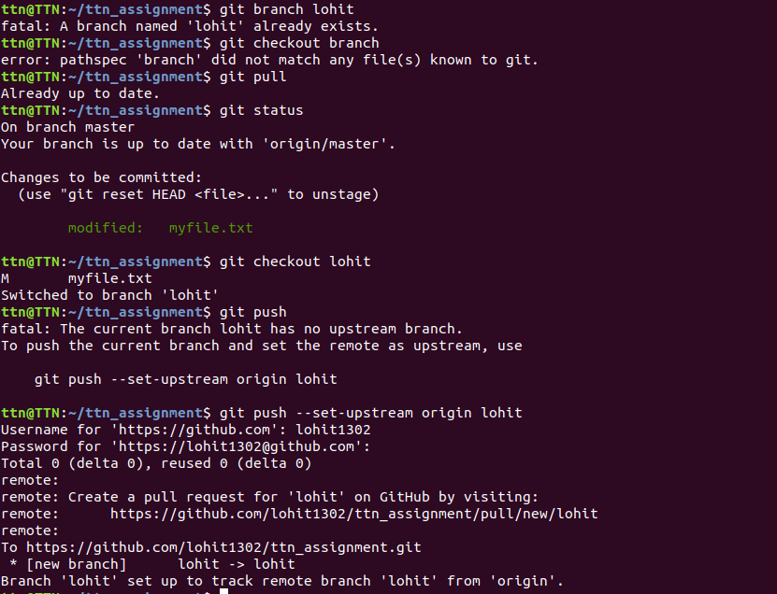
creating a new branch using git branch “Branch Name” or git checkout -b “Branch Name” to checkout into it with creation followed by push.
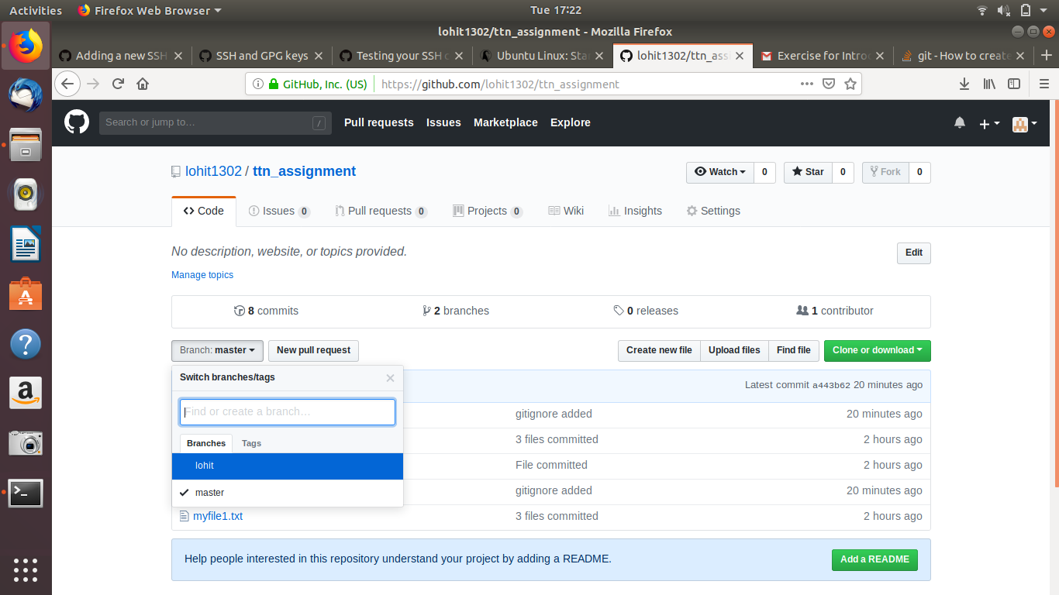

14.

Creating 2 branches with the same commits
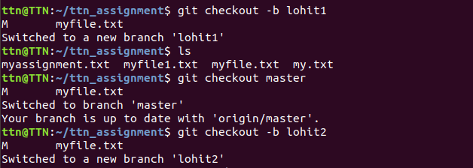

Adding content to remote repository to both the branches
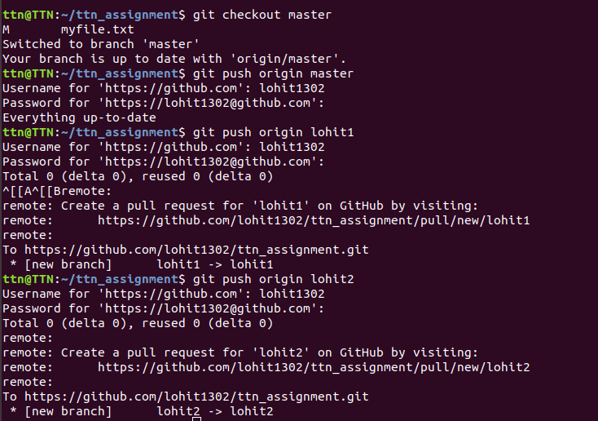

Contents in both the filename


15.
Content in one of the file of the one branch

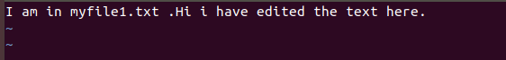

pushing the changes to the remote repository
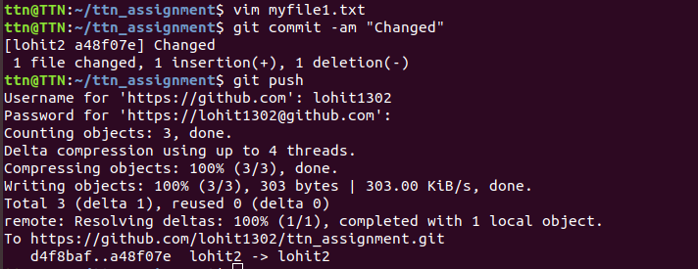

Changing content of the other filename
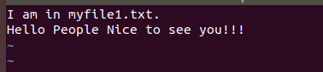

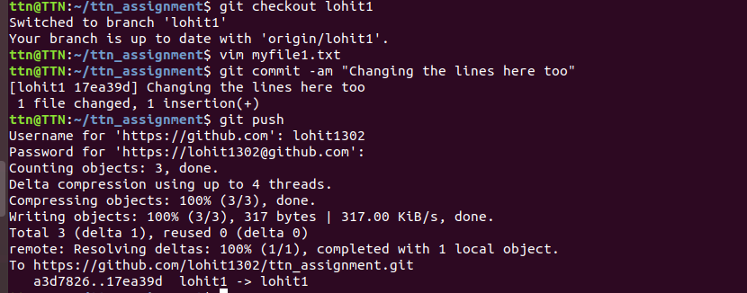
Pushing the content of the other branch in the remote repository

16. Merging the branches and getting the conflict.

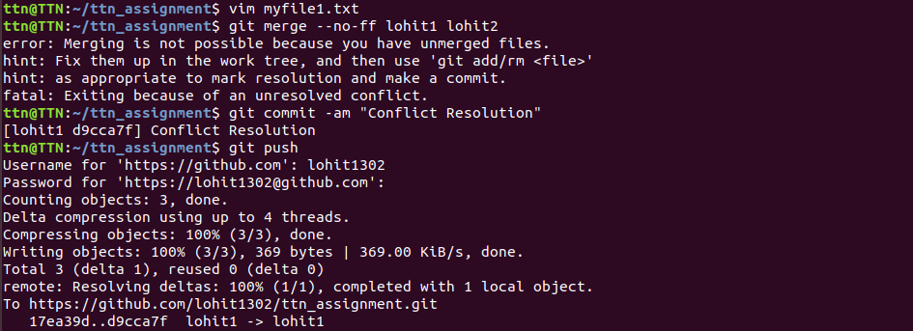

17.
Content of the filename before stashing and adding the content

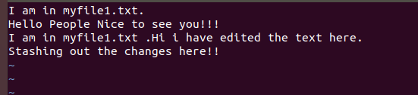

Content of the file originally

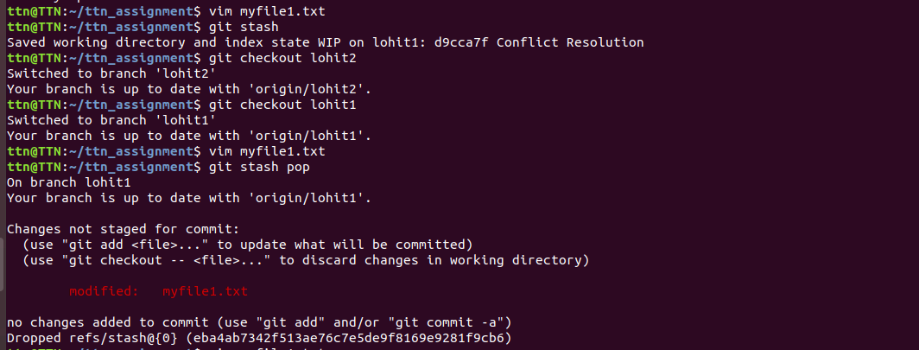
git stash to apply the stash and checkout in the other branch and then coming back to the branch and using git stash pop to pop the content

18. Open bashrc

Adding the code in the bashrc

